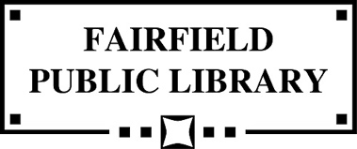  
  
**Naming & Recognition Policy**

1. The purpose of the Naming & Recognition Policy is to enable the Fairfield Public Library Library to encourage and recognize extraordinary generosity on the part of individuals, families, businesses, nonprofit organizations, and other donors as well as to acknowledge exceptional achievement in service to the Fairfield Public Library.
2. Other than as described here, recognition provided to donors or others in support of the Library is the responsibility of the Library Director. This includes naming of specific programs and services; and collection items, equipment, or furnishings purchased with gift money.
3. This policy covers naming of physical spaces and items including, but not limited to: Special use rooms, Collection areas, reading areas, equipment, furniture and art.
4. Naming proposals may be submitted to an ad-hoc committee comprised of the Library Director, Board President, and Foundation President for consideration.
5. Naming and Recognition proposals must include a naming opportunity agreement containing conditions, terms and payment schedule for the contribution. A donor or honoree's name may remain confidential during the review process. If approved by the committee, the Library Board will be informed of the donor's name, the amount of the gift, the area or item to be named, and the general category of the donor (individual, corporation, etc.)
6. The Library Director or any Library Board member may recommend naming an area for other than monetary contributions.
7. Named spaces must include the function of the area, e.g., "Youth Services Area”, or the "Meeting Room" in addition to the donor or honoree's name.
8. The naming of a physical space or item confers no property rights or interest upon the donor, individual or entity. Maintenance, restoration, repair and/or security of the named space or item will be assumed by the Library based on budget and priorities.
9. The Board of Trustees may, at any time, end the named recognition of a physical space or item. Recognition may end if an area is closed, redesigned or repurposed; or an item is replaced. The Board may terminate or alter a naming designation under unusual or extraordinary  
    *Approved by Trustees 3-17-2025*